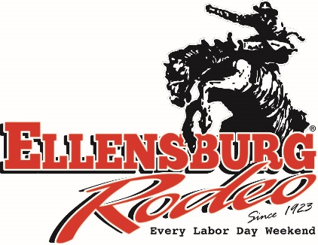

Gold Buckle Club
MEMBERSHIP APPLICATION

Date of application: __________________ Dues: $3,500 first year & $2,100 each year after (fees subject to change)
Membership for 2 people; Minimum 2-year membership
Name(s):_____________________________________ & _____________________________________

Mailing address: ______________________________________ City: ___________________________________

State/Provence: ________ Zip/Postal Code: ____________ Phone(s): ___________________________

Email: ___________________________________________________________

Occupation(s): ________________________________________________________________________

Referred by/friends in the club: _____________________________________________________________

Why I/we wish to be Gold Buckle Club Members:

What is your connection to the Ellensburg Rodeo:

I/We wish to join the Ellensburg Rodeo Gold Buckle Club:

Signature(s) of applicant(s):

1) _____________________________________________ Date: _________________

2) _____________________________________________ Date: _________________

CLUB OBJECTIVES
The Gold Buckle Club was created to provide those who have a special passion for the Ellensburg Rodeo an avenue to enhance and carry forward the tradition of our great rodeo. Gold Buckle members pledge financial support which enables larger purse sizes and improved Rodeo facilities. To

MEMBERSHIP
Membership is open to all who are in good standing in our community. Inappropriate behavior may result in removal from the club. All applications will be reviewed by the Ellensburg Rodeo Board before final approval.
match their passion Gold Buckle members are provided
unique privileges during rodeo and throughout the year.
Return completed application to: Ellensburg Rodeo
609 N. Main Street
Ellensburg, WA 98926

